Alice in Wonderland – References

Pre-Research:

**Origin**

Alice in Wonderland was written in 1865 at the prime time of the mid-19th century by the English Author Charles Lutwidge Dogson under the pseudonym - Lewis Carroll.

Originally this was a story he’d tell the daughters of Henry Liddell (another English Author at the time) as they rowed down the Thames. What initially was a simple story based on fantasy to excited Alice Liddell (one of the Daughters of Henry Liddell) became a well renowned children’s book after Alice badgered Charles to write it down.

REF1: <https://en.wikipedia.org/wiki/Alice%27s_Adventures_in_Wonderland>

**Main topic and history of the story’s evolution**

An article named “Is Alice in Wonderland really about drugs?” on the BBC News website – category Magazine states that throughout the whole story Alice (The character) was under the influence of drugs with quotes saying “The mushroom is "magic" only in the context of the story. And the caterpillar is merely smoking tobacco through a hookah.”

And another quote which raises questions about just how bizarre the world of Alice in Wonderland really is “The Cheshire Cat disappears leaving only the enigmatic grin behind. Alice drinks potions and eats pieces of mushroom to change her physical state. The caterpillar smokes an elaborate water pipe. The whole atmosphere of the story is so profoundly disjointed from reality - surely drugs must have had an influence? After all this was the era of legal opium use.”

REF2: <https://www.bbc.co.uk/news/magazine-19254839>

This bakes the question – was Alice just a child doing drugs, or could the magic be real?

The PG answer, of course not. This is a children’s book that first appealed to one child now a symbol of imagination and pure adventurous fantasy enjoyed by children and adults alike. Especially through American film adaptations like Alice in Wonderland (2010+), Alice in Wonderland (1951) and Alice in Wonderland (1999), all of which have different directions taken from the original concept.

(AIW) 2010+ movies went for a more IMAX blockbuster cinematic experience with flashy visuals and incredible world building.

While (AIW) 1951 went for a more calm but classical approach with slow pacing and acceptable character development, (AIW) 1999 was another take of original novel but tried to bring it more to life and to a modern audience with more humour, colourful environments with rich tones, animatronics for creatures, good lighting and use of CGI.

Art

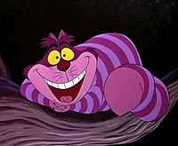

The Cheshire cat in the original cartoon (1951)

* Cartoony and colourful

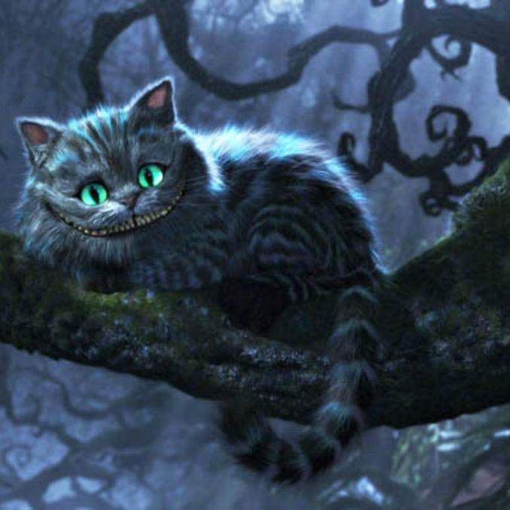

The Cheshire cat in the Tim Burton remake (2010)

* More realistic
* Fewer use of colour

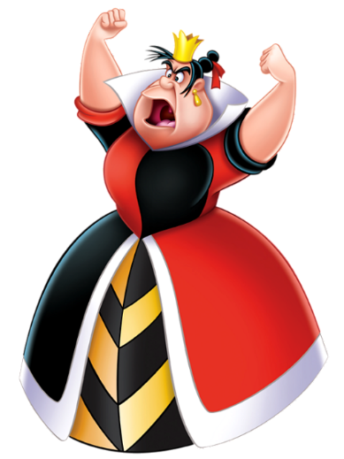

The Queen of Hearts in the original movie (1951)

* Colourful and bright

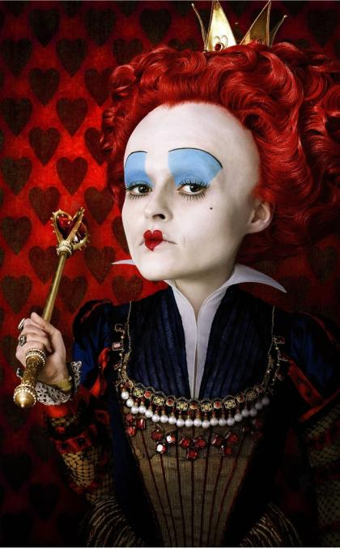

The Queen of Hearts in the Tim Burton remake (2010)

* Darker colours and quite a different design overall

Programming/game mechanics that are relevant or can be used in an Alice in Wonderland game:

Gris - https://store.steampowered.com/app/683320/GRIS/ (The skirt changing into a block to break things can be used with Alice’s skirt if the game were to take influence from GRIS.

Alice – Madness returns: <https://youtu.be/cFrs5UGB-ns>

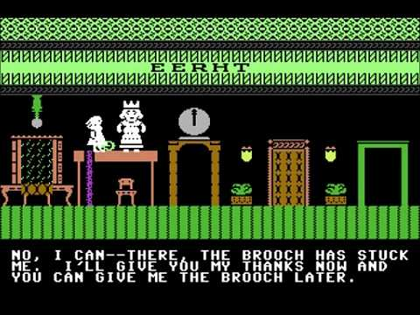The Alice in wonderland c64 game 1985

Audio:

Songs similar to ‘A world of my own’ from the 1951 movie:

Bing Crosby - White Christmas: <https://www.youtube.com/watch?v=w9QLn7gM-hY>

Bing Crosby - As Time Goes On: https://www.youtube.com/watch?v=D6TxoDoOmO4

Dean Martin - Everybody Loves Somebody: https://www.youtube.com/watch?v=z-2_OstpR5c

Frank Sinatra - Have Yourself A Merry Little Christmas: https://www.youtube.com/watch?v=sHVIVNoIPVM

Song that can be used in scenes with the Mad Hatter:

David Lewis Luong - Swing Good Times: https://www.youtube.com/watch?v=ZLtOQrPk4ho

Content in other mediums that were influenced by Alice in Wonderland:

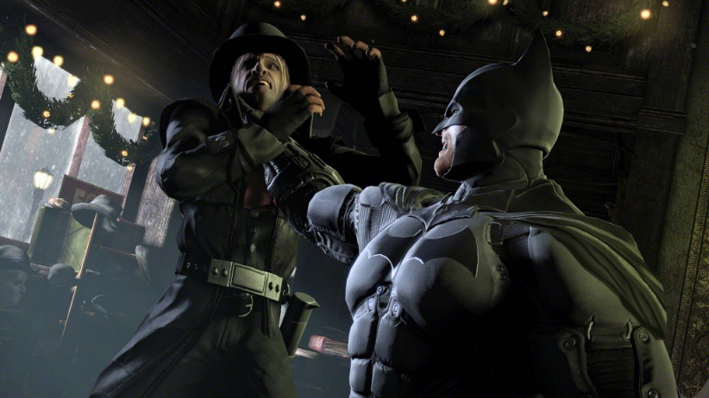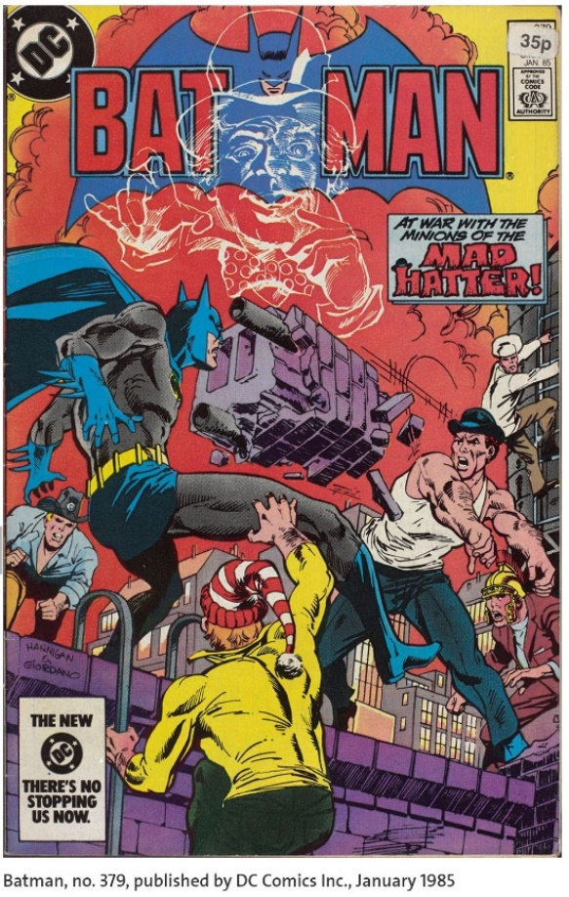Influence in the Batman comics and the Batman Arkham games:

[From Batman Arkham Origins (2013)]

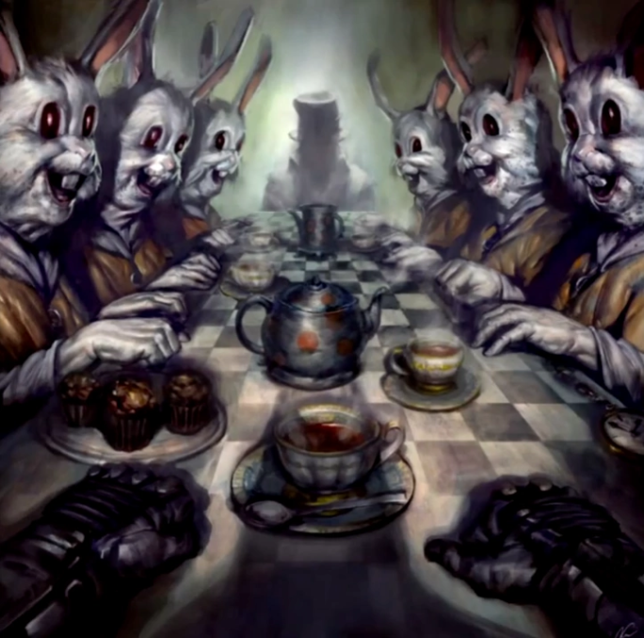

[From Batman Arkham City (2011)]

[From Batman Arkham Knight (2015)]

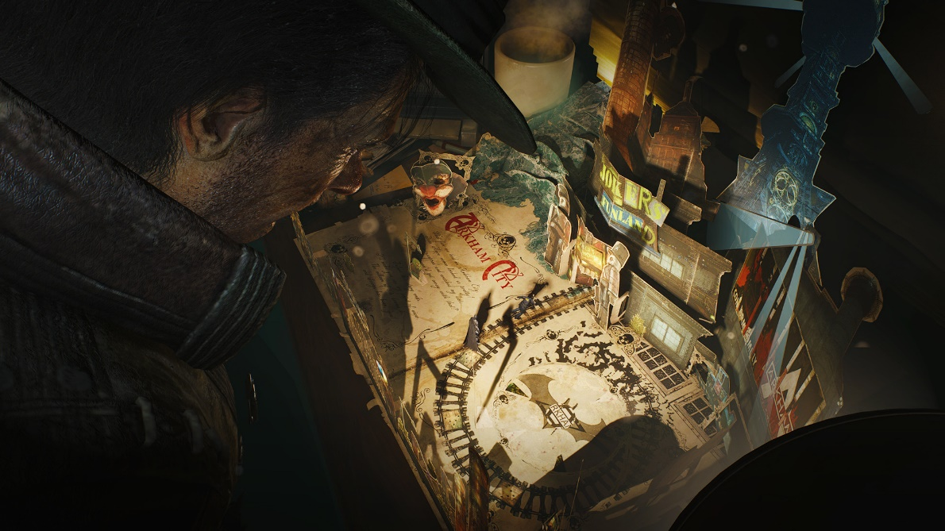

Betty Boop episode: <https://www.youtube.com/watch?v=3GycoEXnBb4>

Scene from Cuphead:

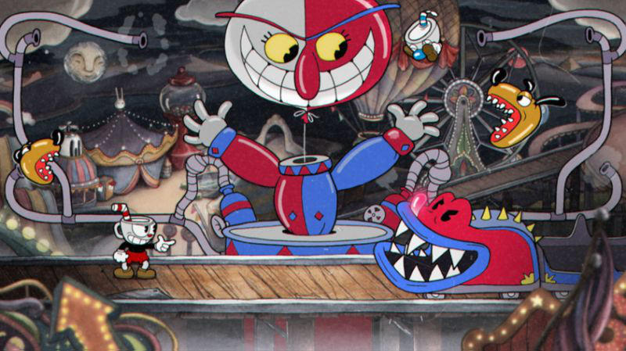

The Mind of Madness in Skyrim

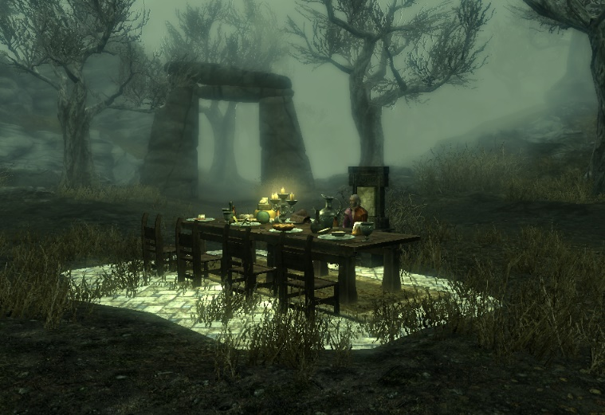

From Alice in Wonderland Looking Through The Glass Manga

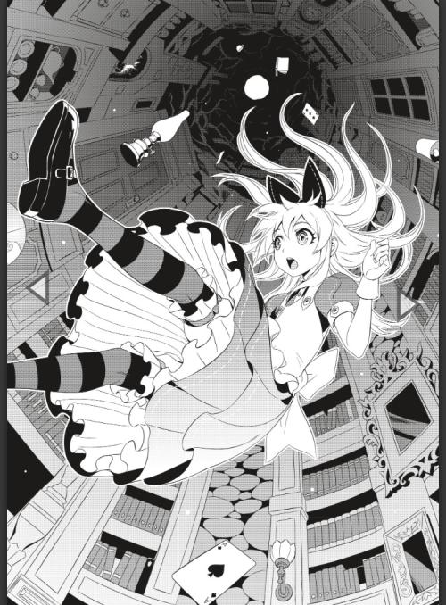

Alice in Wonderland’s influence on video games:

<https://www.theatlantic.com/entertainment/archive/2016/03/alice-in-wonderlands-influence-on-video-games/473082/>

https://www.gamespew.com/2017/03/rabbit-hole-video-games-based-alice-wonderland/